Full Name: John Yee Student ID: 12345

Wells international college

**Project Management**

Assessment Two

|  |  |  |  |
| --- | --- | --- | --- |
| Name of Student | Boi Dinh TRAN | ID | 18190 |

**Assessment 2 – Research (Online)**

Contents

Instructions: 1

Duration: 1

Multiple-choice Questions: 2

Learning Notes: 7

What is project? 7

Please put your learning notes here: 8

Project management basic 8

Project management History 8

Project management in the future 8

Document Search Index 8

## Instructions:

This is an individual assessment. Answer all the questions on the document provided by your Trainer.

## Duration:

Trainer will set the duration of the assessment.

## Multiple-choice Questions:

1. 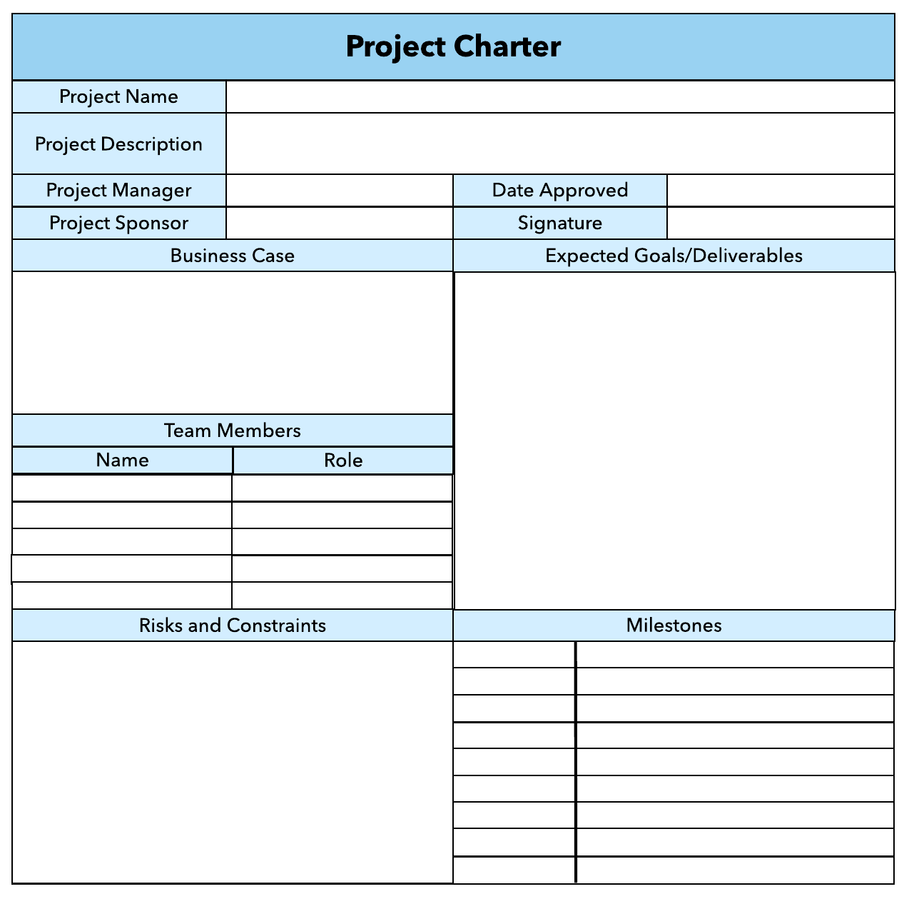What advice do we give about factoring in the commitments of project stakeholders when making your own plans?
   1. Consult student timetables to see when they might be free to attend data collection sessions.
   2. Ask external organizations what the most convenient times would be for you to visit
   3. Neither of these

d) Both A and B

Comment: your plan needs your stakeholders know before implantation.

1. Which of the following are essential components of a GANTT chart used to plan your project?
   1. Your home telephone number
   2. Your supervisor’s home telephone number
   3. The email address for the chair of the ethics committee
   4. None of the above

Comment: in order to get right or good Gantt Char, you need keep concern time, cost, scope and quality. So will get the good requirement and write good Gantt Char.

Web ref: <https://www.proofhub.com/articles/gantt-charts>

1. The intended outcome of strategy/projects integration is
   1. Clear organization focus
   2. Best use of scarce organization resources
   3. Improved communication across projects and departments
   4. Both A and C are correct
   5. A, B, and C are all correct



Comment: **Integration** management is a collection of processes required to ensure that the various elements of the **projects** are properly coordinated. It involves making trade-offs among competing objectives and alternatives to meet or exceed stakeholder needs and expectations.

Web Refer: <https://en.m.wikibooks.org/wiki/Project_Management/PMBOK/Integration_Management>

1. Which of the following questions does the organization's mission statement answer?
   1. What are our long-term strategies?
   2. What are our long-term goals and objectives?
   3. How do we operate in the existing environment?
   4. What do we want to become?
   5. All of these are answered by the mission statement

1. Which of the following is not one of the requirements for successful implementation of strategies through projects?
   1. Allocation of resources
   2. Prioritizing of projects
   3. Motivation of project contributors
   4. Adequate planning and control systems
   5. All of these are requirements

1. Which of the following is the reason(s) why project managers need to understand their organization's mission and strategy?
   1. To make appropriate decisions and adjustments
   2. To be effective project advocates
   3. To be able to get their job done
   4. Both A and B are correct
   5. A, B, and C are all correct

1. Which of these is the highest priority and first strategy required for any organizational change?

a) Communication

* 1. Stress management
  2. Negotiation
  3. Learning
  4. Employee involvement

1. Which of the following is not a procedure to obtain an understanding risk in the planning stage (described in ISA 315):
   1. Inquiries of management
   2. Analytical procedures
   3. Observation and inspection
   4. Procedures for sampling audit tests

1. Assessment of control risk includes three steps. Which of the following is not one of these steps?
   1. Obtaining an understanding of internal controls and documentation of the controls
   2. Evaluate sufficiency and appropriateness of audit evidence
   3. An initial assessment and response to assessed risk based on the design of internal controls resulting in an audit planning memorandum and audit plan
   4. A final assessment based upon test of controls of operating effectiveness

1. Which of the following are not common internal control documentation techniques used by auditors?

a) Questionnaires

* 1. Company internal control manuals
  2. Narrative descriptions
  3. Check lists

1. Overall response to assessed risk may include:
   1. Identify the absence of key controls (where controls are lacking)
   2. Identify existing controls
   3. Incorporating additional elements of unpredictability in the selection of further audit procedures to be performed
   4. Determine potential material misstatements that could result

1. 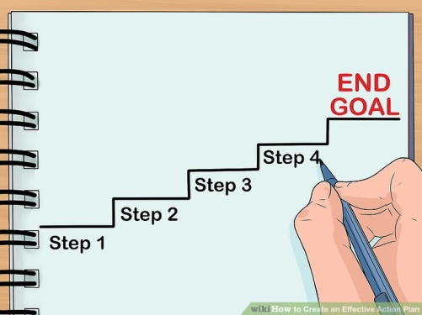Action plan Should be
   1. Specific
   2. Countable
   3. Realistic
   4. Achievable

Comment: An **action plan** is a detailed **plan** outlining actions needed to reach one or more goals. Alternatively, businessdictionary.com defines an **action plan** as a "sequence of steps that must be taken, or activities that must be performed well, for a strategy to succeed".

Web Refer: <https://en.wikipedia.org/wiki/Action_plan>

1. Which of the following is not a function of Project Management Tool?
   1. Plan a project
   2. Manage Tasks
   3. Manage Issues
   4. Time Tracking
   5. Non of above

1. John, the project manager for the ERP Project, is about to complete the project phase review. The completion of a project phase is also known as which of the following? a) A lesson learned
   1. A kill point
   2. Earned value management
   3. Conditional advancement

1. Which of the following is not a key stakeholder in a project that creates a service internal to an organization?
   1. The project manager
   2. External customers
   3. Project vendors
   4. Project team members

1. Managing a project is best described as which one of the following?
   1. Establishing direction
   2. Functional controls over the project team and stakeholders
   3. Consistently producing key results expected by stakeholders
   4. Motivating and inspiring the project team to produce results that are expected by project stakeholders

1. You are the project manager for your organization. Influencing your organization requires which of the following?
   1. An understanding of the organizational budget
   2. Research and documentation of proven business cases
   3. An understanding of formal and informal organizational structures
   4. Positional power

1. What is the difference between a standard and a regulation?
   1. Standards are mandatory; regulations are not.
   2. Standards are optional; regulations are not.
   3. Regulations and standards are essentially the same.
   4. Regulations are usually mandatory; standards may be seen as guidelines.

1. Which of the following is an example of a deliverable at the end of the requirements-gathering phase in a software design project?
   1. Responsibility matrix creation
   2. Detail design document
   3. Business needs
   4. Project team assembled

1. At what point in a project would a kill point be acceptable?
   1. When a project team member is not performing as planned
   2. When a project reaches the end of a project phase
   3. When a project reaches the end of its budget
   4. When a project manager determines the project team cannot continue

1. Of the following, which is not an exit criterion?
   1. Customer sign-offs
   2. Quality metrics
   3. Stakeholder analysis
   4. Regulatory inspections

1. At which point is the risk of failure the least but the consequence of failure the highest?

a) During the early stages

* 1. During the middle stages
  2. During the final stages
  3. Risk of failure is even across all project phases

1. In project estimation, project manager has to provide an expert judgement, which are considered of the following EXCEPT:
   1. Impact of inflation over the project lifecycle
   2. Required labour and labour rates
   3. Material costs and assumptions
   4. Costs of quality
   5. All of above
   6. None of above

1. Which component is/are included in Quality Management Plan
   1. Quality objectives
   2. Key project deliverables
   3. Quality standards
   4. Quality control and assurance activities
   5. All of above

1. What's an activity sequencing
   1. 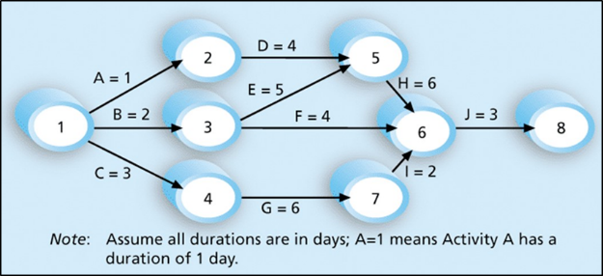The process for identifying and documenting dependencies among schedule activities
   2. The process for identifying critical activities
   3. The process for identifying ordering and schedule activities
   4. The process for planning the project

***Activity sequencing*** reviews all activities in the WBS with the goal of identifying relationships between them and classifying all the timing relationships among tasks. These relationships (aka "linkages", "dependencies", "predecessors"). Task timing relationships are important because they control task sequencing and task start and end dates. There are four types of task relationships:  
A ***finish-to-start relationship***

A ***start-to-start relationship***

A ***finish-to-finish relationship***

A***start-to-finish relationship***

Refer: <https://www.e-education.psu.edu/geog871/l5_p4.html>

Comment: activity sequencing could help make your project stage very clear and easy to follow the project progress. The process for identifying and documenting dependencies among schedule activities

## Learning Notes:

<https://www.youtube.com/watch?v=rBSCvPYGnTc>

<https://www.youtube.com/watch?v=rBSCvPYGnTc&t=1323s>

## What is project?

A project is defined as a sequence of tasks that must be completed to attain a certain outcome. According to the Project Management Institute (PMI), the term Project refers to ” to any temporary endeavor with a definite beginning and end”. Depending on its complexity, it can be managed by a single person or hundreds

Project management is the application of processes, methods, skills, knowledge and experience to achieve specific project objectives according to the project acceptance criteria within agreed parameters. Project management has final deliverables that are constrained to a finite timescale and budget.

Project need you make a big effect in order to achieve a unique or specific goal…

project need show start date or time and finish date or time

## Please put your learning notes here:

The project management lifecycle consists of four steps: initiating, planning, executing, and closing.

The purpose of project management is to plan and manage a project to successfully complete its listed goals and deliverables. It involves identifying and managing risks, careful resource management, smart budgeting, and clear communication across multiple teams and stakeholders.

Project management is important because it brings leadership and direction to projects. Without project management, a team can be like a ship without a rudder, moving but without direction, control, or purpose. Leadership allows and enables team members to do their best work.

## Project management basic

## Project management History

20 Century the Henry Gantt first make Gantt Chart Diagram. It is the revolution to know more about project management.

## Project management in the future

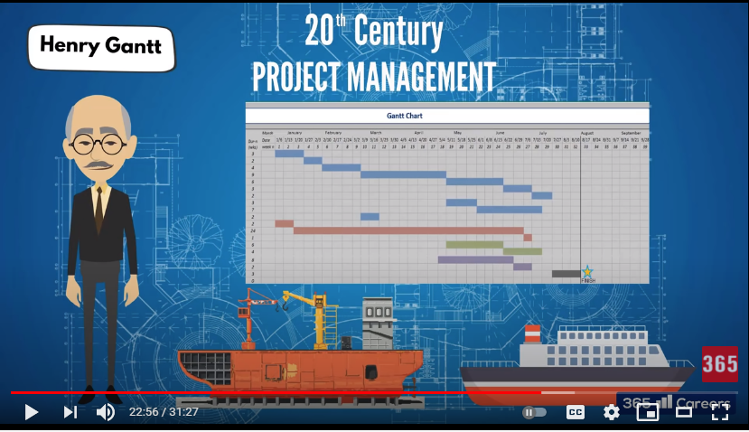

## Document Search Index

A

a GANTT chart 2

M

mission and strategy 3

mission statement 3

O

organizational change 3

P

project stakeholders 2

projects integration 2

S

successful implementation 3

U

understanding risk 4